Pressure Sand Filters System

[Home](https://www.cleantechwater.co.in/)  Pressure Sand Filters System

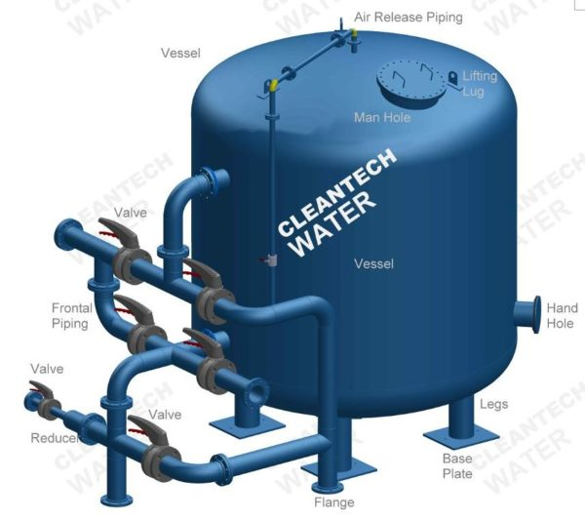Pressure Sand Filters used in wastewater treatment plants remove nonionic impurities like clay, turbidity, dust, particles, heavy metals suspended solid matter, etc. from water & wastewater. In pressure sand filters generally, quartz sand is used for filtration supported with gravels &pebbles ideal for sediment turbidity, sand, clay, etc.

Our simple but well-engineered media-based filter acclaims stringent design, High performance, less pressure drop across the bed, longevity, and optimum utilization of surface area ensure us to gain more and more clients’ satisfaction.

Construction of Our Pressure Sand Filter

We engineer state-of-the-art pressure sand filters to provide robust and efficient solutions to our customers. Our filters are meticulously crafted to meet modern water treatment demands. With innovation and premium quality materials, our filters can withstand the test of time and effectively remove impurities from water sources.

Our pressure sand filter comprises a durable outer shell that protects its internal components.  
The carefully selected sand media serves as the primary filtration agent, capturing contaminants as water passes through. This combination of durability and effective filtration ensures a reliable and low-maintenance solution for your water purification needs.

The Process

Our pressure sand filters are integrated with a highly effective filtration process. Water is directed into the filter, where it seeps through the layer of sand. As water passes through the sand media, suspended particles, sediment, and even some microorganisms get trapped within the sand grains. The purified water then exits the filter, ready for various applications, from industrial processes to potable consumption. Periodic backwashing of the sand bed helps rejuvenate its filtering capacity, making the filter a long-lasting and efficient choice.

Why Invest in Our Pressure Sand Filters

* **Outstanding Filtration Efficiency:** Our pressure sand filters ensure a high level of particle removal, making them ideal for applications that demand crystal-clear water quality.
* **Durable Build:** Crafted from sturdy materials, our filter is thoughtfully designed to endure harsh operating conditions, minimising maintenance requirements and ensuring longevity.
* **Versatility:** From residential setups to industrial complexes, our filters act as the ideal solution for a wide range of filtration needs while adapting to varying operating environments.
* **User-Friendly:** Easy installation and user-friendly operation make our filter an accessible choice for both professionals and novices in the field of water treatment.
* **Cost-Effective:** With its low maintenance needs and exceptional reliability, our filter presents a cost-effective solution in the long run.
* [Specification](https://www.cleantechwater.co.in/pressure-sand-filters/#1484038701505-4c13938d-5c8c)
* [Application](https://www.cleantechwater.co.in/pressure-sand-filters/#1484038701530-ed217e49-85a1)
* [Download](https://www.cleantechwater.co.in/pressure-sand-filters/#1484039064257-47645314-a835)
* Available in Vertical and horizontal
* Designed to meet the stringent requirements of clients
* Filter up to 20 – 30 Microns
* Well-designed bed collection system
* Operate at optimum velocity requires
* High removal of suspended solids.
* Material of construction MS/FRP/MSRL/SS
* Designed as per ASME or IS
* Well-designed distribution system
* Well-designed collection system
* High-end water quality

Frequently Asked Questions About Pressure Sand Filter

Why are the Applications of Your Pressure Sand Filter Systems?

You can use our pressure sand filter system to remove turbidity and suspended particles from the water and wastewater. This simple yet effective system uses multiple layers of sand with a variety in size and specific gravity. Our pressure sand filter system can filter up to 20-30 microns.

Is the System Available in Different Variants?

Yes, our pressure sand filter system is available in vertical and horizontal variants based on your requirements. The material used for the construction of the system includes MS, FRP, MSRL, and SS. With a well-designed collection and distribution system, you can consult with our water treatment experts to let us know your needs.

Can I Use this System for Pre and Post Treatment of Wastewater?

Yes, you can use our pressure sand filter system for pre and post-treatment of wastewater as well as for rainwater harvesting. Our system is highly recommended for the removal of suspended solids and undissolved impurities such as dust particles and heavy metals.

Can This Plant Handle Commercial Water Treatment Applications?

Yes, our plant is designed to handle a variety of residential, commercial, and industrial water treatment applications. Our pressure sand filter system uses media-based sand filters with a stringent design that helps you treat wastewater, swimming pool water, and more cost-effectively and efficiently.

Invest in Our Pressure Sand Filter

Investing in our pressure sand filter guarantees clean and healthy water and peace of mind. Backed by our reputation for delivering top-notch water treatment solutions, this filter stands as a reliable partner in your journey towards superior water quality.